CHAPTER 18: METAFILES
Metafiles vs Bitmaps
Metafiles are like vector graphics, while bitmaps are like raster graphics. Metafiles are built from a series of binary records corresponding to graphics function calls, whereas bitmaps are made of pixels, usually from real-world images. Essentially, metafiles describe how to draw, and bitmaps describe what is already drawn.
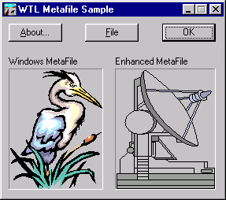
I. Creating and Editing
Paint programs create bitmaps, while drawing programs create metafiles.
In a drawing program, you can easily move or edit individual graphical objects because they are stored as separate records.
In a paint program, you are generally limited to moving or removing rectangular sections of the bitmap.
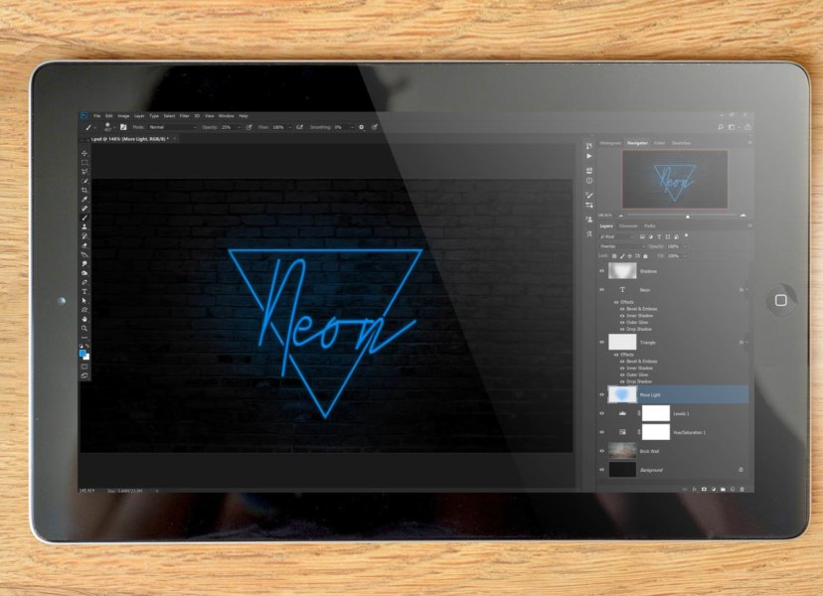

II. Scaling
Metafiles can be scaled to any size without losing resolution because they are based on drawing commands.
Bitmaps cannot be scaled without losing quality, as enlarging them stretches the pixels.
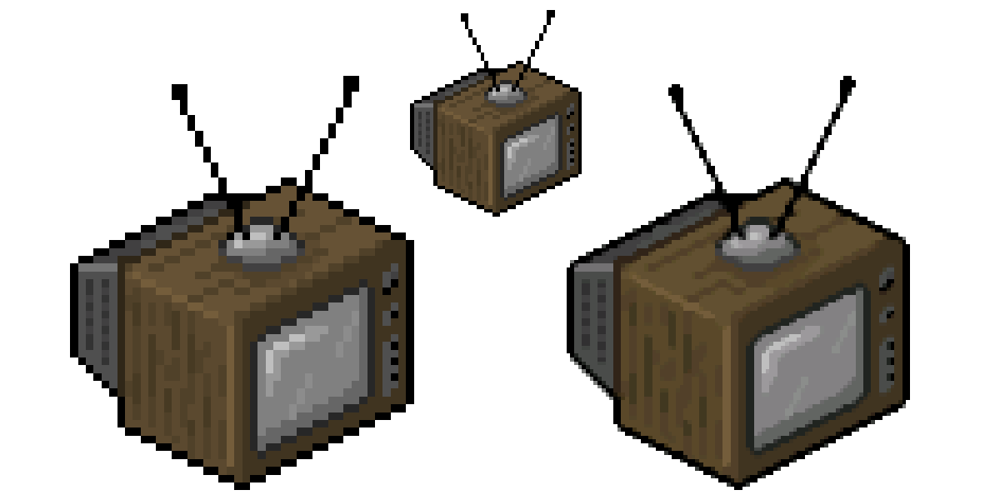
III. Converting
You can convert a metafile into a bitmap, but some detail may be lost. Converting a bitmap into a metafile is much harder and usually requires a lot of processing.
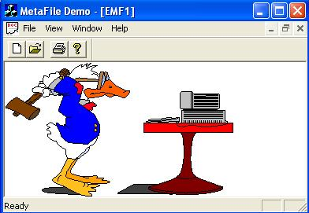
IV. Uses
Metafiles are commonly used for sharing images between programs through the clipboard. They can also exist on disk as clip art.
Metafiles are smaller in size and more device-independent than bitmaps, making them the preferred format for sharing and storing images.

V. Windows Metafile Formats
Windows supports two metafile formats.
The original metafile has been available since Windows 1.0.
The enhanced metafile was developed for 32-bit Windows and includes several improvements over the old format.
It is recommended to use the enhanced metafile whenever possible.
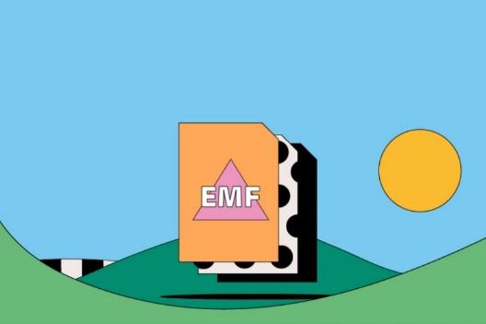

UNDERSTANDING THE OLD METAFILE FORMAT
Metafiles: Blueprints for Vector Graphics
A metafile stores drawing commands, not pixel data, acting as a blueprint for recreating an image.

Advantages over bitmaps:
- Device Independence: Looks the same on screens, printers, and other devices.
- Compactness: Less storage needed, especially for simple graphics.
- Scalability: Can resize without losing quality since commands are recalculated.

Working with Memory Metafiles
I. Create a Metafile Device Context (MDC):
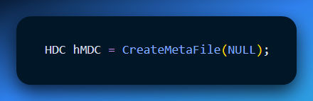
Provides a virtual canvas to record drawing commands.
II. Draw Using GDI Functions:
Functions like LineTo, Rectangle, TextOut, etc., are recorded, not displayed immediately.
III. Close the MDC:
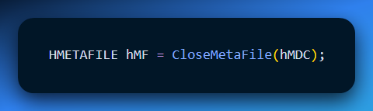
Finalizes the metafile and returns a handle for later use.

Rendering (Playing) a Metafile
I. Get a Real Device Context:
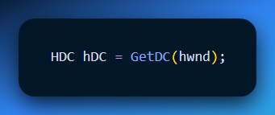

II. Play the Metafile:
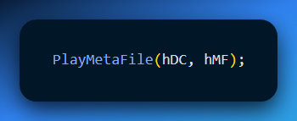
Executes the recorded GDI commands, rendering the image on the target device.

Saving as a Disk Metafile
CreateMetaFile accepts a filename to save the metafile on disk:
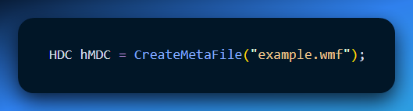
- Windows handles the file I/O automatically.
- If NULL is passed, the metafile stays in memory.

Key Points to Remember
- Metafiles record commands, not pixels.
- Memory metafiles are temporary; disk metafiles persist for later use.
- The old WMF format works, but Enhanced Metafile (EMF) is preferred for modern applications.

METAFILE.C – Essentials 🎨
I. Core Idea
- Metafiles store drawing commands, not pixels, allowing you to replay graphics multiple times (like a “macro” for GDI drawing).
- METAFILE.C demonstrates in-memory metafiles, then shows how to switch to disk-based metafiles for large drawings.
II. Program Flow
- Create Metafile
  - Use CreateMetaFile(NULL) for memory-based, or CreateMetaFile("example.wmf") for disk-based.
  - Record GDI commands: rectangles, lines, ellipses, fills, etc.
- Playback
  - WM_PAINT triggers PlayMetaFile to draw the recorded commands on the window.
  - Anisotropic mapping mode allows flexible scaling and viewport shifts.
  - Can tile or reuse the same metafile multiple times efficiently.
- Cleanup
  - CloseMetaFile finalizes the metafile.
  - DeleteMetaFile deletes the handle (memory metafiles) without touching disk files.
  - DeleteFile removes the disk file if desired.
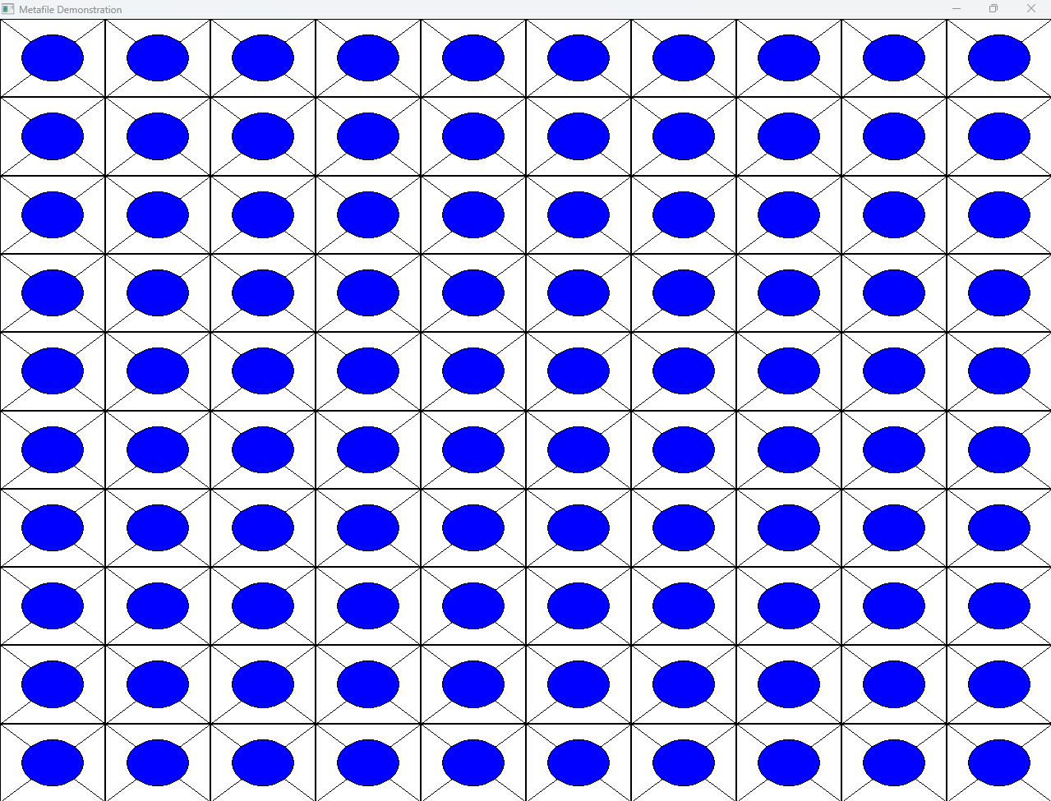
III. Advanced Concepts
- Disk vs Memory Metafile: Disk reduces RAM use but needs file access each time.
- METAFILEPICT: Wraps an old metafile with mapping mode and dimensions for clipboard operations. Provides:
  - Scaling information
  - Mapping flexibility
  - Clipboard compatibility
- Clipboard Tips:
  - Copy: Put METAFILEPICT structure on clipboard.
  - Paste: Retrieve, adjust mapping if needed, play with PlayMetaFile.

IV. Challenges & Notes
- Old WMF format has limitations:
  - Hard to determine size from handle alone
  - Limited clipboard flexibility
- Enhanced Metafile (EMF) is preferred for modern apps (more features, better scaling, broader compatibility).
- Performance: For very large graphics, consider alternative formats (bitmaps) for speed.

V. Takeaways for WinAPI Coding
- Think in commands, not pixels. Metafiles record actions, not final results.
- Resource management is key. Always close and delete metafiles, fonts, brushes, and pens to avoid leaks.
- Use mapping modes wisely. Anisotropic mapping lets you scale and tile, but you must manage coordinate systems.
- Experiment safely. Disk vs memory, clipboard, and tiling are all ways to explore how WinAPI handles graphics efficiently.

METAFILES AND THE CLIPBOARD
This chapter deals with a complex problem: How do you copy a drawing from one program (like Excel) and paste it into another (like Word) while keeping the size correct?
If you just copy pixels (Bitmap), the image gets blurry when resized.
If you copy commands (Metafile), the image stays sharp, but you need to tell the other program how big the drawing is supposed to be.

I. The Structure: METAFILEPICT
A raw Metafile is just a list of commands (Draw Line, Draw Circle). It has no concept of "Physical Size." To fix this, Windows wraps the metafile in a structure called METAFILEPICT before putting it on the clipboard.
It contains 4 fields:
- mm: The Mapping Mode (e.g., Millimeters, Inches, Pixels).
- xExt: The Width of the image.
- yExt: The Height of the image.
- hMF: The Handle to the Metafile itself.

II. Creating the Metafile (The Copy Side)
When your program wants to copy a drawing to the clipboard:
Step A: Create the Metafile
- Call CreateMetaFile(NULL) to create a metafile in memory (not on disk).
- Set the Window Origin (SetWindowOrgEx) and Extent (SetWindowExtEx) if you are using scalable modes.
- Draw your picture using standard GDI calls.
- Close it with CloseMetaFile.

Step B: Wrap it in METAFILEPICT
- Allocate global memory (GlobalAlloc) for the structure.
- Fill in the mm, xExt, and yExt fields.
  - Recommendation: Use MM_ANISOTROPIC. This gives the receiving program the most freedom to resize the image.
- Store the Metafile Handle (hMF) inside.
Step C: Put on Clipboard
- OpenClipboard -> EmptyClipboard.
- SetClipboardData(CF_METAFILEPICT, hGlobalMemory).
- CloseClipboard.

III. Playing the Metafile (The Paste Side)
When your program wants to paste a drawing:
Step A: Get the Data
- OpenClipboard.
- GetClipboardData(CF_METAFILEPICT).
- Lock the memory to read the structure.
Step B: Setup the Environment You cannot just play the metafile blindly. You must prepare your Device Context (DC) to match the settings of the original drawing.
- SaveDC: Always save your current state so the metafile doesn't mess up your app.
- SetMapMode: Read the mm field from the structure and set your DC to match it.
Step C: Handle the Size (The Hard Part)
- If the mode is Fixed (e.g., MM_LOMETRIC): The drawing has a specific physical size (e.g., 5cm x 5cm). Use the xExt and yExt values to set a Clipping Rectangle so the drawing doesn't bleed over your other content.
- If the mode is Scalable (MM_ISOTROPIC / ANISOTROPIC): The drawing is stretchy. Use SetViewportExtEx to force the drawing to fit into the specific box where the user clicked "Paste."

Step D: Play
- PlayMetaFile(hdc, hMF).
- RestoreDC.
- Clean up handles.

IV. Key Rules for Developers
The Coordinate Logic
- MM_TEXT (Pixels): Good for icons. Bad for printed documents.
- MM_ISOTROPIC: Keeps the aspect ratio (a circle stays a circle). Good for logos.
- MM_ANISOTROPIC: Stretches freely. Good for charts that need to fill a specific rectangle.
Zero vs. Non-Zero Dimensions
- If xExt is 0, it means "I don't care about size. Stretch me to fill the whole screen."
- If xExt is Positive, it suggests a preferred size.
Memory Efficiency Always use Memory-Based Metafiles (CreateMetaFile(NULL)) for the clipboard. Do not try to pass a file path on the clipboard; it is slow and unreliable.

V. Summary Checklist
- Copy: Wrap your HMETAFILE inside a METAFILEPICT structure.
- Paste: Read the Mapping Mode (mm) first.
- Setup: Call SetMapMode to match the source.
- Scale: Use SetViewportExtEx to map the image size to your destination rectangle.
- Play: Call PlayMetaFile.

UNDERSTANDING PREPAREMETAFILE
This function prepares the device context so a metafile can be played correctly.
It makes sure the drawing keeps the right size and shape by handling scaling and aspect ratio properly.

I. Matching Mapping Modes:
The first thing it does is make sure the device context uses the same mapping mode as the metafile.
This is important because mapping modes control how the metafile’s logical coordinates are converted into screen coordinates.
If they don’t match, the drawing may appear stretched or misplaced.

II. Handling Isotropic and Anisotropic Modes:
Special care is taken when the mapping mode is MM_ISOTROPIC or MM_ANISOTROPIC.
These modes allow more control over scaling, which helps keep the correct proportions of the drawing.
This is especially useful when the metafile needs to look consistent on different screen sizes or resolutions.

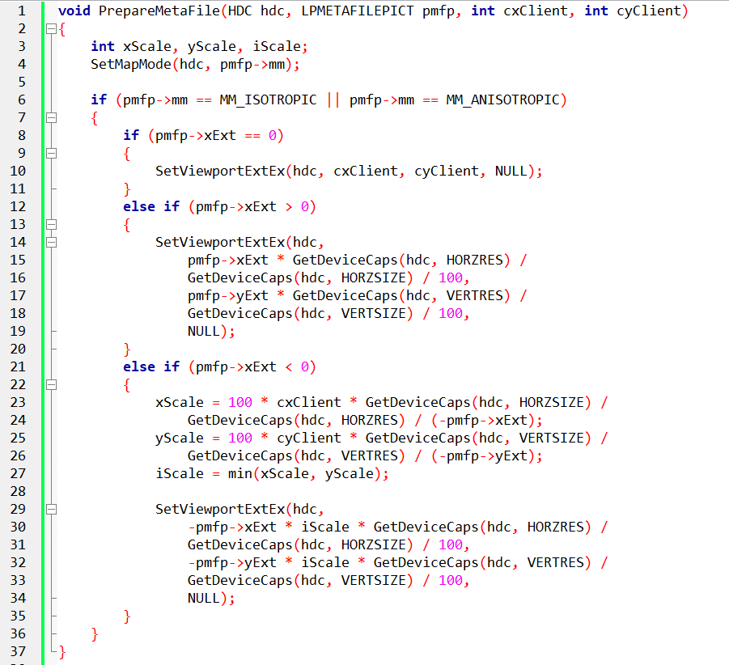

Metafile Playback & Extent Handling
I. Interpreting xExt / yExt Values
Metafiles may provide suggested size and/or aspect ratio using xExt and yExt from METAFILEPICT.
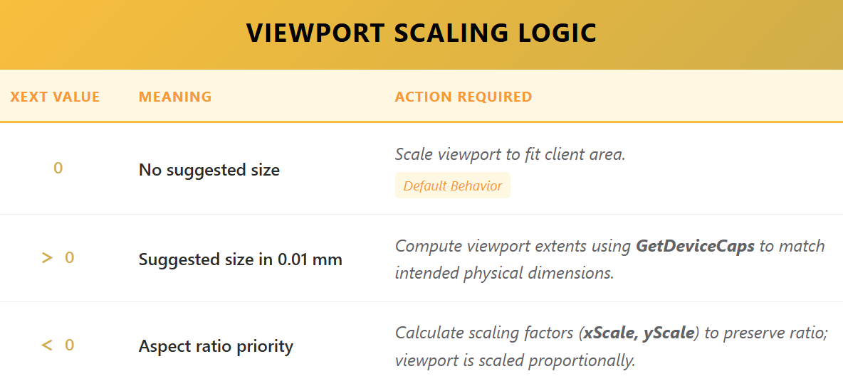
Tip: Always check mapping mode (mm) because it affects how logical units convert to device units.

II. Optional Viewport Origin
- Use SetViewportOrgEx(hdc, xOrigin, yOrigin, NULL) if you need precise placement of the metafile in the client window.
- Otherwise, default origin (0,0) is fine.

III. Playing the Metafile
Prepare device context:
Execute drawing:
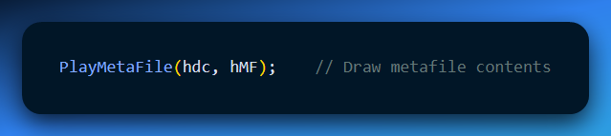
Restore DC:
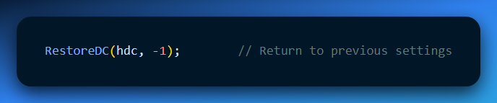
IV. Releasing Resources
- Memory unlock: GlobalUnlock(hGlobal) – free the memory block holding the metafile data.
- Close clipboard: CloseClipboard() – allows other apps to access the clipboard.
Always do this to prevent leaks and ensure system stability.

V. Enhanced Metafile (EMF) Considerations
- Windows automatically converts older metafile formats to EMF if needed.
- Clipboard exchange handles format translation for you.
- Viewport origin can still be controlled for precise placement.
- Resource management is the same: unlock memory, close clipboard, delete handles if created.

VI. Key Takeaways for WinAPI Coding
- Understand extent values (xExt, yExt) → critical for scaling & aspect ratio.
- Always check and set mapping mode before playing a metafile.
- Viewport origin control gives precise positioning flexibility.
- Resource cleanup is non-negotiable: memory unlock, clipboard close, delete handles.
- EMFs make life easier — Windows handles format conversions automatically.

💡 Pro Tip: Think of xExt/yExt + mapping mode + viewport as a recipe for translating metafile coordinates to actual pixels. Once you nail that, rendering any metafile correctly on any display becomes straightforward.

ENHANCED METAFILES (EMF) – THE 32-BIT UPGRADE 🚀
I. Why EMFs Exist
- 32-bit Windows improvement over WMFs. Designed to overcome limitations of old WMFs (like poor scaling, limited graphics support, sparse headers).
II. Key Features
- New Functions & Structures → more control over drawing and playback.
- Distinct Clipboard Format → CF_ENHMETAFILE.
- File Extension → .EMF.
- Rich Header Info:
  - Device context settings
  - Image dimensions
  - Embedded object sizes
  - Color management
  - Thumbnail previews
  - Application-specific metadata
Impact: Apps can optimize playback, scale precisely, and manage advanced graphics efficiently.
III. Compatibility
- Windows can convert EMF ↔ WMF for older apps.
- ⚠️ Not all EMF features survive the downgrade → paths, regions, enhanced text may be lost.
IV. Workflow / Procedure
- Create → CreateEnhMetaFile(hdc, filename, ...)
- Draw → Standard GDI functions within metafile context
- Close → CloseEnhMetaFile(hmf) → returns handle
- Play → PlayEnhMetaFile(hdc, hmf) → renders the drawing
V. Advantages Over WMF
- Advanced Graphics → better text handling, regions, and paths
- Scalability → resolution-independent, no pixel distortion
- Compactness → smaller file sizes
- Extensibility → store app-specific data in the metafile

💡 Takeaway: EMFs = modern, flexible, precise, and smaller metafiles with richer headers. Once you switch to EMFs, you get better scaling, better graphics, and easier clipboard integration, while still being able to interact with older WMF-based systems if needed.

EMF1.C – ENHANCED METAFILE ESSENTIALS ⚡
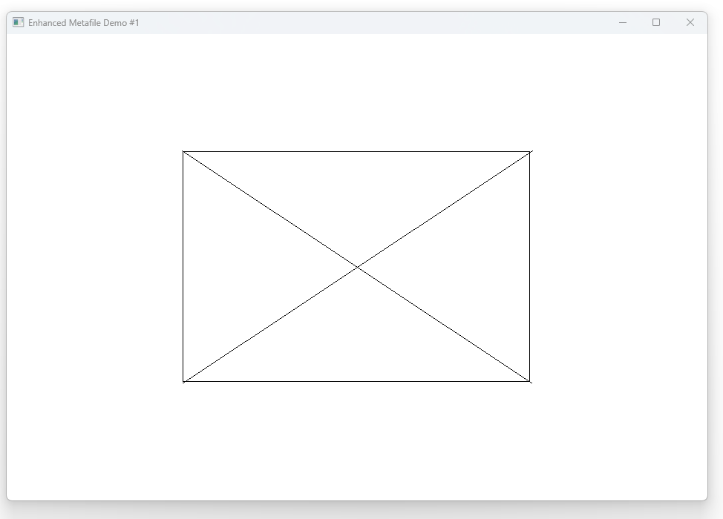
I. Window Setup
- Window Class Registration: Sets up a window named "EMF1" with default sizes/positions.
- Message Loop: Keeps the program responsive to input, resizing, and system events.
II. Creating an EMF (WM_CREATE)
- CreateEnhMetaFile → returns a special DC for recording drawing commands.
- Draw Commands → Rectangle, MoveToEx, LineTo create shapes on the metafile.
- CloseEnhMetaFile → finalizes the metafile and gives you a handle for playback.
III. Playing the EMF (WM_PAINT)
- BeginPaint / Device Context → gets the drawing canvas.
- Central Display → focus playback in a rectangle within the window.
- PlayEnhMetaFile → replays drawing commands.
- Stretching → GDI automatically scales the image to fit the rectangle (can distort).
IV. Cleaning Up (WM_DESTROY)
- DeleteEnhMetaFile → releases memory used by the metafile.
- Ensures no memory leaks and smooth exit.
V. Core Concepts
- Coordinate Independence: Only the relative positions of shapes matter; absolute numbers can be adjusted.
- Image Stretching: Flexibility vs. fidelity — stretching can distort shapes but allows fitting into any rectangle.
- Preserving Aspect Ratio / Size: Important for precise visuals (e.g., technical drawings, police sketches).
- Line-Rectangle Mismatch: Windows may misalign lines vs. rectangle corners; a known quirk to fix if needed.

VI. Advanced Takeaways
- EMFs vs. WMFs: EMFs are more robust, support advanced graphics, and scale better.
- Flexible Playback: You can place EMFs in different rectangles without losing relative geometry.
- GDI Role: Handles both drawing and scaling, making metafile usage practical and versatile.
- Cross-Platform Note: Other systems use formats like SVG; EMFs are mainly Windows-specific.
💡 TLDR
- EMFs record drawing commands into a device-independent format.
- CreateEnhMetaFile → draw → CloseEnhMetaFile → store handle → PlayEnhMetaFile to display.
- Coordinates are relative; you can scale/stretch to fit.
- Balance accuracy (aspect ratio, exact size) vs flexibility (fit any rectangle).
- Always clean up resources with DeleteEnhMetaFile.

EMF1 VS EMF2 VS EMF3 – CORE DIFFERENCES & LESSONS 🔥
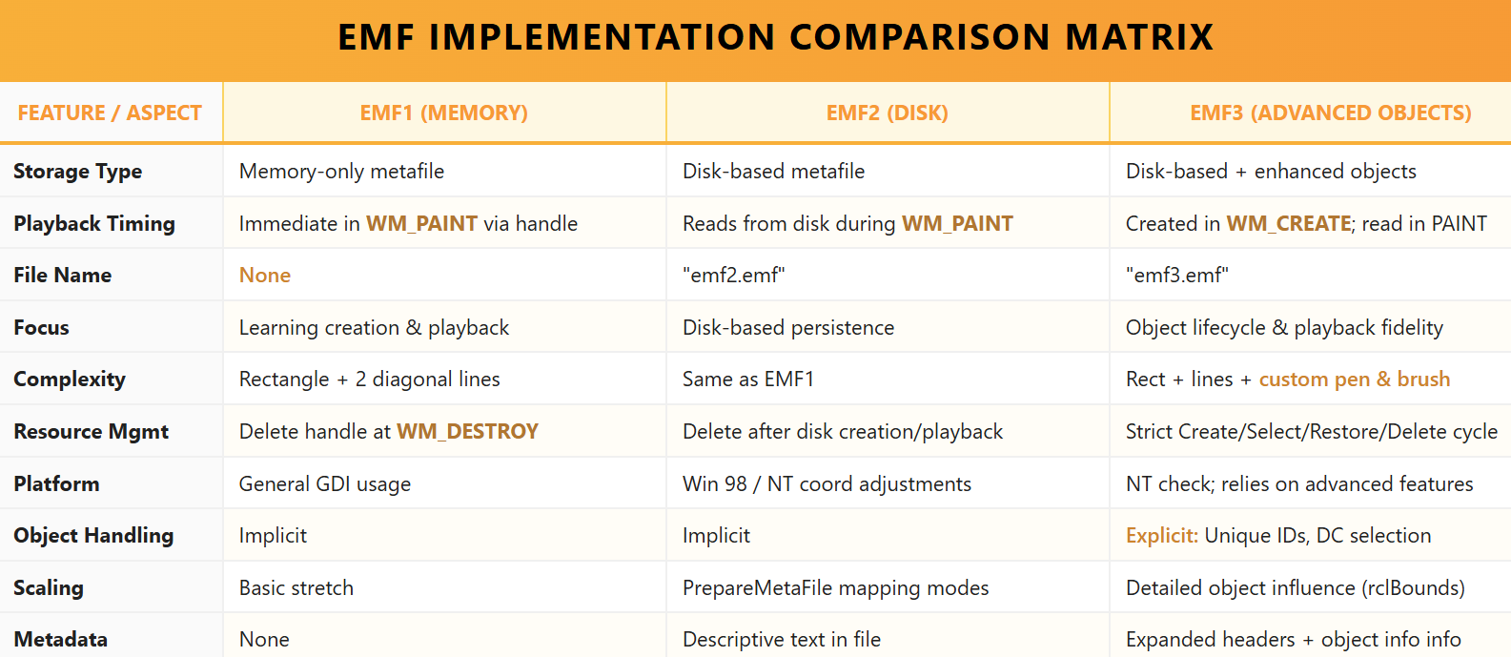
NB: Find the html for this table in this folder.
I. Key Best Practices for Metafile Resource Management✅
- Delete Objects After Use
  - Always call DeleteObject on pens, brushes, and other GDI objects after they’re no longer needed.
  - Prevents leaks and reduces metafile size during playback.
- Restore Default Objects
  - After drawing with custom pens/brushes, restore stock objects via SelectObject.
  - Ensures the DC is ready for future operations and prevents conflicts.
- Limit Object Creation
  - Avoid creating unnecessary pens or brushes. Reuse them whenever possible.
  - Reduces memory usage and file size.
- Handle Disk vs Memory
  - Use disk-based metafiles when you need to inspect, share, or reuse the file later.
  - Memory-based metafiles are fast for transient rendering but lost on program exit.
- Prepare for Different Mapping Modes
  - For MM_ISOTROPIC / MM_ANISOTROPIC, calculate scaling factors to preserve aspect ratio.
  - For other modes, use clipping rectangles based on xExt / yExt.

II. Using Unique Identifiers for Non-Default Objects
- What They Do: Each custom pen/brush/etc. gets a unique ID in the metafile.
- How to Use: During playback, SelectObject(hdc, objectID) lets you choose that exact object. Change properties, reuse objects, or selectively draw parts of the metafile.

Example:
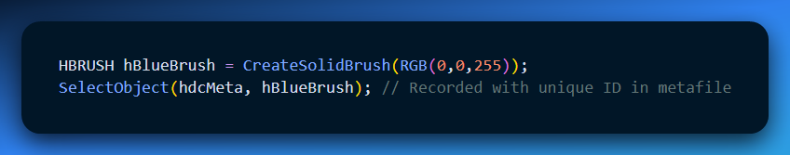
Later, you can reuse that exact brush during playback or for another metafile section without recreating it.

III. Stock Objects in Metafiles
- Predefined objects, identified by high-bit-set IDs in EMR_SELECTOBJECT records.
- Examples:
  - Stock Pens: Black pen, default width
  - Stock Brushes: White brush, hollow brush
  - Stock Fonts: ANSI_FIXED_FONT, SYSTEM_FONT, DEFAULT_GUI_FONT
- Benefit: Saves memory, reduces metafile size, no need to explicitly create them.

IV. EMF3 Structural Insights
- EMF3 stores pen & brush definitions explicitly (EMR_EXTCREATEPEN, EMR_CREATEBRUSHINDIRECT).
- Selection and deletion are recorded (EMR_SELECTOBJECT, EMR_DELETEOBJECT) → ensures full playback fidelity.
- Hex dumps show the exact sequence of GDI calls, giving insight into:
  - Object creation order.
  - Drawing commands.
  - Resource cleanup.
- rclBounds adjusts for pen thickness → affects drawing boundary.
- nHandles shows how many objects are stored → increased in EMF3 vs EMF2 due to extra objects.

V. Summary Lessons
- EMF1: Simple, in-memory creation and immediate playback; good for learning basics.
- EMF2: Introduces disk persistence; good for inspecting file contents and learning storage concepts.
- EMF3: Shows real-world metafile management — custom objects, proper selection/deletion, mapping modes, scaling, and object IDs.
💡 Big Picture: As you move from EMF1 → EMF3, the focus shifts from basic drawing to structured resource handling and object lifecycle, which is essential for production-level GDI graphics programming.

EMF4 PROGRAM – REVAMPED OVERVIEW ✨
I. Purpose & Key Features
- Bitmap Integration: EMF4 demonstrates how bitmaps can be embedded into enhanced metafiles, expanding the range of graphics beyond simple shapes.
- Disk-Based Persistence: The metafile is created and saved to disk (emf4.emf), allowing inspection and delayed playback.
- Playback Flexibility: Supports scaling, repositioning, and consistent rendering on different devices using device-independent bitmaps (DIBs).

II. Window Creation & Initialization
- Registers a standard window class and creates the main window.
- Sets up the environment for drawing and playback.

III. WM_CREATE – Capturing the Bitmap
Metafile Creation:
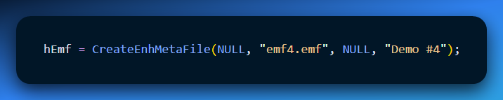
Prepares an enhanced metafile to record drawing commands.
Load Bitmap from System Resources:
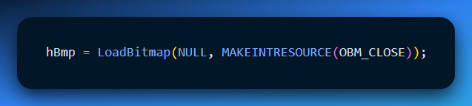
Retrieves the standard “close button” bitmap.
Bitmap Information & Memory DC:
- GetObject obtains width, height, and other properties.
- CreateCompatibleDC creates a temporary memory DC for manipulating the bitmap before recording.
Select & Transfer Bitmap:
- Select bitmap into memory DC with SelectObject.
- Copy it into the metafile DC at (100, 100) with size 100x100 using StretchBlt.
- This action is recorded into the metafile, including scaling and placement.
Resource Cleanup:
- Delete memory DC: DeleteDC.
- Delete bitmap object: DeleteObject.

Finalize Metafile:
- Close with CloseEnhMetaFile.
- Delete handle from memory using DeleteEnhMetaFile. The file on disk still contains all content.

IV. WM_PAINT – Recreating the Scene
- Prepare canvas with BeginPaint.
- Retrieve client area dimensions using GetClientRect.
- Center the metafile in the window for balanced display.
- Load metafile from disk: GetEnhMetaFile("emf4.emf").
- Render metafile to DC with PlayEnhMetaFile, including the embedded bitmap.
- Release resources: DeleteEnhMetaFile.
- End painting: EndPaint.

V. Core Takeaways
- Metafiles are versatile: Can capture both GDI commands and embedded bitmaps.
- Memory DCs matter: Act as intermediate canvases for bitmap manipulation before recording into a metafile.
- Persistence: Content remains in disk metafile even after deletion from memory.
- Playback flexibility: Size, position, and device-independent scaling can be adjusted during WM_PAINT.

VI. Handling Bitmaps – GDI Strategies
Indirect Objects: Functions like LoadBitmap and CreateCompatibleDC aren’t recorded directly. Instead:
- Bitmap data is stored as an indirect object inside the metafile.
- Dimensions, color depth, and other attributes are saved for accurate playback.
Playback Methods:
- Direct: StretchDIBits uses the embedded DIB data directly.
- Reconstruction: CreateDIBitmap builds a device-dependent bitmap (DDB) and then uses StretchBlt for rendering.

VII. Metafile Structure
- Header: Signature, bounds, EMF version, descriptive text (“Demo #4”).
- StretchBlt Record: References bitmap indirect object, source & destination rectangles, ROP code.
- Bitmap Data: Stored as a DIB (device-independent bitmap), self-contained for portability.
- EOF Record: Marks end of metafile.

VIII. Key Lessons for Graphics Programming
- Efficiency: Record only essential drawing commands for playback; avoid storing the entire bitmap handling process.
- Portability: DIBs allow bitmaps to play back correctly across different devices and contexts.
- Resource Management: Clean up temporary DCs and objects to prevent leaks.
- Playback Strategies: Understand GDI’s dual approach to rendering bitmaps for both speed and device compatibility.

✅ Summary:
EMF4 elevates metafiles to handle real-world graphics like bitmaps efficiently, emphasizing playback-centric design, portability, and proper resource management. Think of it as EMF3 plus bitmap embedding and sophisticated GDI handling.
CLOSING THE EMF SERIES: PROGRAMS 5, 6, AND 7 🎬
This final group of programs explores what you can really do with Enhanced Metafiles beyond basic playback. The focus moves from simple rendering to control, transformation, and embedding.

I. EMF5 — Controlled Playback (Enumeration)
EMF5 renders the same output as EMF3, but it uses a different approach.
Instead of playing the metafile in one call, it enumerates the metafile record by record.
Each drawing instruction is processed individually through a callback function. During enumeration, each record is executed using PlayEnhMetaFileRecord.
This method gives fine-grained control over playback. You can inspect records, skip them, or decide when and where they are rendered.
The visual result is the same as EMF3. The difference is control.
Key idea:
EMF5 proves that enumeration is about how you play a metafile, not what it draws.

II. EMF6 — Transforming Records During Playback
EMF6 takes enumeration a step further by modifying drawing commands while the metafile is being played.
As each record is enumerated, the program checks whether it is a rectangle drawing command. If it is, the record is copied into temporary memory. The copy’s record type is changed from rectangle to ellipse. The modified copy is then played instead of the original.
The original metafile is never changed. Only the copied records are altered.
This approach preserves the integrity of the metafile while allowing creative transformations during rendering.
EMF6 also introduces the importance of the GDI handle table. GDI objects such as pens and brushes are tracked internally and reused correctly during playback.
Key idea:
EMF6 shows how enumeration can be used to transform graphics safely.

III. EMF7 — Embedding Graphics into a New Metafile
EMF7 is different from everything before it.
Instead of modifying playback, it creates a brand-new metafile that embeds new graphics into existing content.
The program creates a new metafile device context and enumerates the original metafile into it. While enumeration is happening, extra drawing commands are injected directly into the new metafile. In this case, a green ellipse is added when a rectangle record is encountered.
The original metafile remains untouched. A new metafile is saved to disk containing both the original drawings and the embedded graphics.
During enumeration, non-visual records such as the header and EOF are skipped. GDI state is preserved by saving and restoring pens and brushes.
When the window repaints, the program simply plays the newly created metafile.
Key idea:
EMF7 demonstrates non-destructive metafile composition.

IV. Big Picture Summary 🧠
EMF3 plays a metafile all at once.
EMF5 plays it record by record.
EMF6 modifies records during playback.
EMF7 writes new content into a new metafile.
Enumeration is the foundation behind all advanced EMF techniques. Once you understand it, you can inspect, filter, transform, and even generate new metafiles programmatically.
That’s the real power of EMF.

EMFVIEW PROGRAM
Note the first thing I did was convert the regular .bmp file to .emf file using:
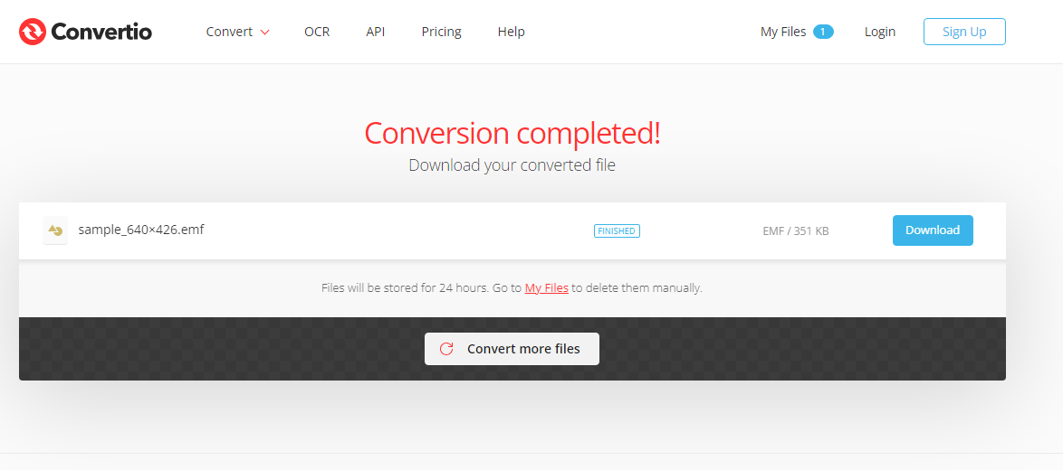
…or any other tool online. Loaded as a regular .bmp


Loaded as a .emf file:
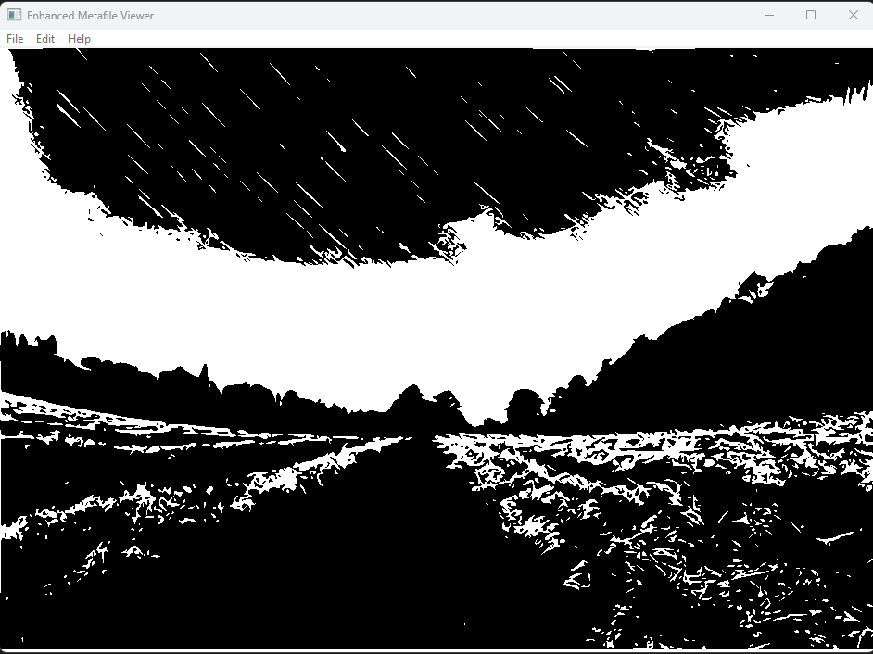
The about:
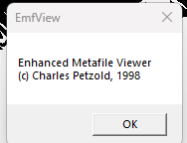
What EMFVIEW Really Is (No Fluff)
Strip all the ceremony away and EMFVIEW is just this:
EMFVIEW = A Windows app that loads an EMF, shows it, lets you copy/save/print it, and displays its metadata.
That’s it. Nothing mystical. No hidden wizardry.
Everything else is just Windows plumbing.

Core Responsibilities (Plain English)
I. Open & Display an EMF
- Uses GetEnhMetaFile
- Stores the handle
- Calls PlayEnhMetaFile in WM_PAINT
- Stretches it to fit the window
👉 Viewer logic

II. Save / Duplicate an EMF
- Uses CopyEnhMetaFile
- Writes a new .emf file
👉 File I/O wrapper

III. Print an EMF
- Opens printer dialog (PrintDlg)
- Gets printer DC
- Starts a document (StartDoc → StartPage)
- Plays the metafile into printer bounds
- Ends page and doc
👉 Same drawing, different DC
This is the big WinAPI lesson:
Screen DC and Printer DC are just output targets.

IV. Clipboard Support
- Copy / cut uses CopyEnhMetaFile
- Paste pulls EMF from clipboard
- Delete clears the handle
👉 Standard Windows clipboard behavior

V. Properties Dialog
- Calls GetEnhMetaFileHeader
- Dumps:
  - Bounds
  - Frame
  - Resolution
  - Record count
  - Handle count
  - Palette entries
👉 Metadata inspection
This is literally just reading the header.

VI. Palette Handling (Old-school but important)
- Extracts palette from EMF
- Selects & realizes it
- Responds to:
  - WM_QUERYNEWPALETTE
  - WM_PALETTECHANGED
👉 Color correctness on limited hardware.
Not cool, but historically critical.

VII. The Printing “Problem” You Noticed Is REAL
You caught something important 👀
Thin vector lines:
- Look fine on screen
- Disappear on high-DPI printers
That’s not a bug. That’s physics.
Fix: use thicker pens when printing.
EMF doesn’t magically know your intent.
That’s pro-level awareness, by the way.

VIII. The Scaling Truth (This Is the Key Insight)
Metafiles scale well because they are instructions, not pixels.
But:
- Embedded bitmaps don’t scale infinitely
- Raster fonts don’t scale cleanly
- Aspect ratio can be destroyed if you’re careless
That’s why:
- Header info matters
- Bounding rectangles matter
PlayEnhMetaFile(hdc, hemf, &rect);
That rectangle is the contract.

IX. Ultra-Compressed
If I had to reduce EMFVIEW to 10 lines of notes, it’d be this:
- EMFVIEW loads, displays, prints, and copies EMF files.
- Uses GetEnhMetaFile and PlayEnhMetaFile.
- Printing uses the same playback logic on a printer DC.
- Clipboard uses CopyEnhMetaFile.
- Properties come from GetEnhMetaFileHeader.
- Scaling is controlled by the bounding rectangle.
- Vector graphics scale cleanly; bitmaps don’t.
- Thin lines may vanish on high-DPI printers.
- Palettes ensure color accuracy on limited systems.
- Same drawing logic, different output targets.
That’s it. No overthinking.
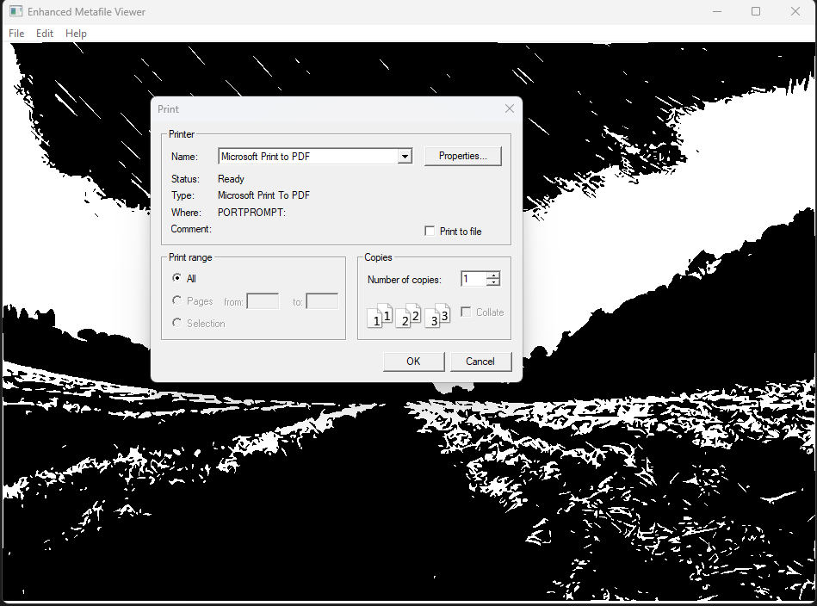
EMF8.C and EMF.C: DEMONSTRATES ACCURATE DISPLAY OF A 6-INCH RULER METAFILE.
Think of metafiles like recipes for drawing pictures.
Regular image formats (JPEG, PNG) are like pre-cooked meals: You just open them and see the finished picture. You can't really change them much.
Metafiles are like the recipe: They tell you how to draw the picture step-by-step, using lines, shapes, and colors.

Here's the key difference:
With a regular image: If you want to make the picture bigger, it might get blurry or pixelated. You can't really change its details.
With a metafile: You can stretch it to any size without losing quality! The recipe just uses bigger or smaller numbers for the lines and shapes. You can even change the colors or add new details easily.

Here are some real-world uses of metafiles:
Logos: Company logos often use metafiles because they can be resized for different uses without losing their sharpness.
Maps: Online maps can use metafiles to draw the map features (streets, buildings, etc.) because you can zoom in and out without it getting blurry.
Printers: Printers use metafiles to understand how to draw the pages you send them, even if you change the font size or layout.

So, to sum it up:
- Metafiles are like recipes for drawing pictures.
- They can be resized without losing quality.
- They are used in logos, maps, and printing.

Enhanced Metafile Fundamentals:
Vector-Based Graphics: Unlike bitmap formats (e.g., JPEG, PNG), which store pixel-by-pixel information, EMFs store a series of drawing commands that can be executed to reproduce the image.
Scalability: This vector-based nature grants EMFs exceptional scalability. They can be resized without losing clarity, making them ideal for scenarios demanding adaptability.
Device Independence: EMFs maintain consistent quality across different devices and resolutions, ensuring the intended visual appearance is preserved.

EMF8.C PROGRAM
Deeper Exploration of Key Functions:
DrawRuler:
This function is responsible for drawing the ruler with tick marks and numbers on a device context (HDC). It uses various GDI functions such as CreatePen, Rectangle, MoveToEx, LineTo, CreateFontIndirect, and TextOut to create the visual elements of the ruler.
Pen Selection: The choice of a black pen with a 1-point width aligns with typical ruler design conventions, ensuring visual clarity and familiarity.
Tick Mark Variability: The use of different tick mark lengths effectively communicates various measurement increments, enhancing the ruler's usability.
Font Choice: "Times New Roman" is a classic and easily readable font, well-suited for displaying numerical values in a clear and concise manner.

CreateRoutine:
This function is called to create the EMF file. It starts by creating an enhanced metafile (EMF) using the CreateEnhMetaFile function. The EMF file is given the name "emf8.emf" and a description "EMF8\0EMF Demo #8\0".
The function then retrieves the device capabilities (GetDeviceCaps) to determine the size and resolution of the device. It calls the DrawRuler function to draw the ruler on the EMF. Finally, it closes the EMF file with CloseEnhMetaFile and deletes the temporary EMF handle with DeleteEnhMetaFile.
DPI Awareness: The conversion of dimensions to dots per inch is crucial for ensuring accurate scaling and rendering of the ruler, especially when displayed on devices with varying resolutions.

PaintRoutine:
This function is called to paint the contents of the EMF file onto the specified device context (HDC) within the given area. It retrieves the handle to the EMF file using GetEnhMetaFile and obtains the header information of the EMF file using GetEnhMetaFileHeader.
The dimensions of the image are calculated based on the bounds of the EMF file. The function then uses PlayEnhMetaFile to render the EMF file onto the device context within the specified rectangle. Finally, it deletes the EMF handle with DeleteEnhMetaFile.
Header Information: Extracting the ruler's dimensions from the metafile header enables precise placement and sizing within the window's client area, maintaining visual consistency.
Centered Rendering: The calculation of a centered rectangle for metafile playback contributes to visual balance and symmetry, enhancing the overall presentation.

Contextual Significance:
Metafile Versatility: The EMF8.C program effectively showcases the versatility of EMFs for storing and reproducing graphical content in various contexts.
Graphics Programming Foundation: Understanding the principles demonstrated in this program serves as a valuable foundation for further exploration of graphics programming techniques and Windows API graphics capabilities.

Additional Considerations:
- Alternative Metafile Formats: While EMFs offer distinct advantages, other metafile formats, such as Windows Metafiles (WMF) or Scalable Vector Graphics (SVG), have their own unique properties and use cases.
- Metafile Handling in Modern Systems: Contemporary operating systems and graphics frameworks often provide advanced tools and libraries for working with metafiles, streamlining their creation, manipulation, and integration into applications.
- Performance Optimization: In scenarios where performance is critical, careful consideration should be given to the potential overhead associated with metafile creation and playback, as well as potential optimizations for specific use cases.

EMF.C PROGRAM
The code includes necessary header files and defines external functions.
The WinMain function is the entry point of the program. It registers a window class, creates a window, and enters the message loop.
The WndProc function is the window procedure that handles various messages sent to the window, such as WM_CREATE, WM_COMMAND, WM_SIZE, WM_PAINT, and WM_DESTROY.
The WM_CREATE message is handled by calling the CreateRoutine function to perform any necessary initialization.
The WM_COMMAND message is handled to process menu commands. In particular, the IDM_PRINT command triggers the PrintRoutine function, which initiates the printing process. The IDM_EXIT command closes the application, and the IDM_ABOUT command displays information about the program.
The WM_SIZE message is handled to update the client area dimensions when the window is resized.
The WM_PAINT message is handled by obtaining a device context (hdc), calling the PaintRoutine function to perform painting operations, and then releasing the device context.
The WM_DESTROY message is handled to post a quit message and exit the message loop, terminating the program.
The PrintRoutine function is responsible for printing the contents of the window. It displays a print dialog, retrieves the printer device context, determines the page dimensions, starts a print job, and calls the PaintRoutine function to draw the content onto the printer device context.
The CreateRoutine function is an external function that is responsible for any necessary initialization. Its implementation is not provided in the code you shared.
The PaintRoutine function is an external function that performs the actual drawing operations. Its implementation is not provided in the code you shared.

Key Concepts:
Device Contexts (DCs): Abstract drawing surfaces, crucial for both screen and printer output in Windows graphics programming.
Message Loop: The heart of a Windows application, responsible for receiving and processing user input, system events, and drawing requests.
Window Procedure (WndProc): A function that handles messages specific to a window, defining its behavior and interactions.
Printing Pipeline: Involves obtaining a printer DC, initiating the printing process, rendering content using appropriate functions, and finalizing the document.

Code Structure:
Modular Design: The separation of core functions (WinMain, PrintRoutine, WndProc) promotes code clarity and maintainability.
External Dependencies: The reliance on application-specific files for EMF content and drawing logic highlights the framework's versatility.
Error Handling: The inclusion of error-checking mechanisms, such as the message box for printing errors, enhances user experience and aids in troubleshooting.

Additional Considerations:
Historical Context: The Windows NT requirement reflects the specific EMF capabilities of that operating system at the time of the program's creation.
Compatibility and Adaptation: Understanding the program's structure and dependencies is essential for adapting it to modern operating systems or alternative graphics libraries.
Customization Potential: The framework's modular nature invites experimentation with different EMF creation and playback techniques, fostering a deeper understanding of vector graphics principles.

Further Exploration:
Graphics Programming: Investigate Windows API graphics functions for drawing lines, shapes, text, and images, as well as advanced techniques like coordinate transformations and color management.
Metafile Formats: Explore the properties and use cases of other metafile formats, such as Windows Metafiles (WMF) and Scalable Vector Graphics (SVG), to choose the most suitable format for different applications.
Cross-Platform Development: Consider graphics libraries like Qt or wxWidgets for creating cross-platform applications with support for vector graphics and metafiles.

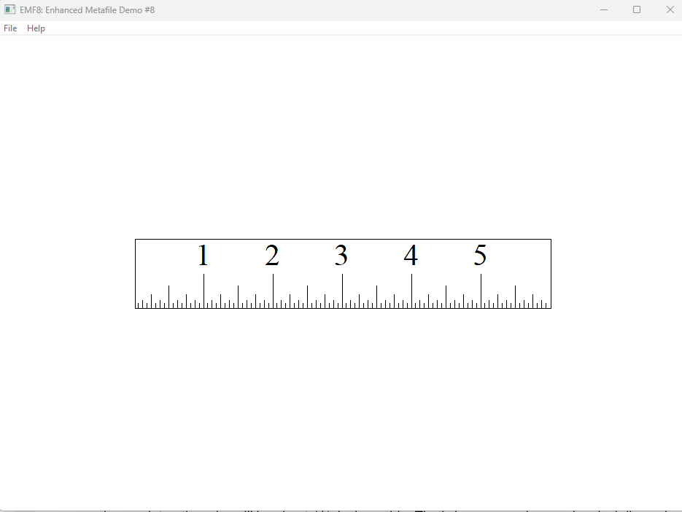

RECAP OF THE PROGRAM ABOVE:
Metafile Creation and Playback:
When: The program creates a metafile containing a ruler image during the WM_CREATE message.
How: It calls an external function named CreateRoutine to generate the metafile.
Where: The metafile is displayed both on-screen (during WM_PAINT) and printed (when the user selects the print command).

Resolution and Scaling:
Challenge: Accurate rendering of the ruler requires knowledge of device resolution, as printers often have higher resolution than displays.
Reference Device: The CreateEnhMetaFile function uses a reference device context (usually the video display) to determine device characteristics.
Calculating DPI: The code obtains device dimensions in millimeters and pixels, and calculates dots per inch (DPI) for accurate scaling.

Header Information:
Bounding Rectangle: The PaintRoutine function retrieves the metafile header using GetEnhMetaFileHeader.
Purpose: The header contains the rclBounds field, which specifies the image's size in pixels.
Centering: This information is used to center the ruler image within the client area, ensuring proper visual alignment.

Screen vs. Print Discrepancy:
On-screen Display: The ruler drawn with the video display's resolution as reference might not perfectly match a physical ruler's size due to display limitations discussed in Chapter 5.
Printing Issue: When printed on a high-resolution printer (e.g., 300 DPI), the ruler appears 11/3 inches wide instead of the intended 6 inches because the pixel-based size was used.

Metafile Header Rectangles:
rclBounds: Used in EMF8, specifies the image size in pixels, but leads to inaccurate printing on different resolutions.
rclFrame: Contains the image size in 0.01 millimeters, offering device-independent information for accurate scaling.

Reference Device Context:
Determines the relationship between pixel and millimeter dimensions in the header.
In this case, the video display acts as the reference, leading to pixel-based size in EMF8.

Solution and Next Steps:
EMF9 program utilizes the rclFrame information from the metafile header for accurate ruler rendering on various devices.
This example highlights the importance of using the appropriate rectangle field and understanding the reference device context impact.

Further Exploration:
- Experiment with EMF9 to see how the ruler scales accurately on different resolutions.
- Investigate other metafile formats and their header information for flexible image handling.
- Learn more about reference device contexts and their role in scaling and device independence.

Key Takeaways from EMF8 program:
- Metafile Flexibility: Metafiles, like EMFs, offer versatility in displaying and printing images due to their device-independent nature.
- DPI Awareness: Accurate rendering requires understanding device resolution and scaling images accordingly.
- Header Metadata: Metafile headers contain valuable information, such as bounding rectangles, which can be used for precise positioning and scaling of images.

EMF9 PROGRAM
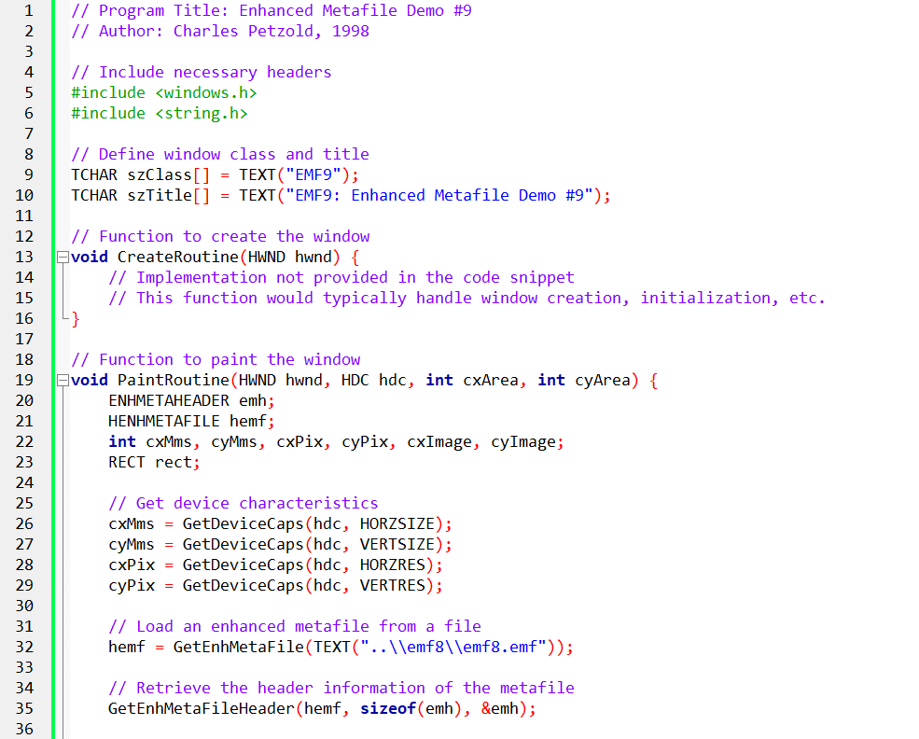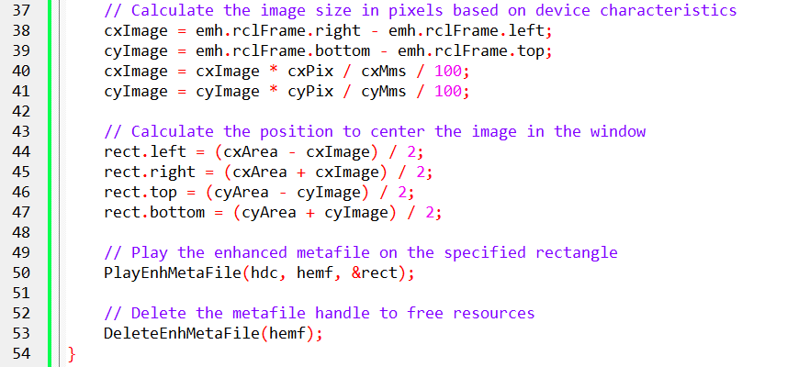

Imagine a digital ruler that always measures correctly, even when printed on different devices:
- This code makes it happen by using a special format called an Enhanced Metafile (EMF).
- It's like storing the ruler's drawing instructions instead of a simple picture.
- The instructions include measurements in millimeters, ensuring accuracy.

Here's how it works:
Load the Ruler's Blueprint: The code opens the EMF file, which contains the ruler's design and measurements.
Check the Output Device: It examines the screen or printer to figure out its resolution (how many dots or pixels it can display per inch).
Calculate the Right Size: Using the device's resolution, it converts the ruler's measurements from millimeters to pixels to ensure it looks correct on that specific device.
Position the Ruler: It calculates the best spot to center the ruler within the window or page.
Draw the Ruler: It follows the EMF's instructions to carefully draw the ruler lines, numbers, and tick marks in the correct size and position.
Clean Up: It tidies up by closing the EMF file to save memory.
The result: A ruler that always measures 6 inches wide and 1 inch tall, whether you see it on the screen or print it on paper!

1. Application Structure:
The code seems to be structured around two main functions: CreateRoutine and PaintRoutine. The former is likely responsible for creating and initializing the window, while the latter handles the painting of the window with an enhanced metafile.

2. Window Creation (CreateRoutine):
Unfortunately, the details of the CreateRoutine function are not provided in this snippet. In a typical Windows application, this function would involve creating a window, setting up the necessary structures, and handling any initialization required for the application.

3. Metafile Loading and Drawing (PaintRoutine):
The PaintRoutine function is more detailed and appears to be responsible for loading an enhanced metafile and drawing it on the window's device context.
Metafile Loading:
- The code loads an enhanced metafile from a file using the GetEnhMetaFile function. The filename is specified as "..\emf8\emf8.emf".
- The GetEnhMetaFileHeader function retrieves information about the metafile, particularly the dimensions and other characteristics.
Device Characteristics:
- The code then retrieves characteristics of the device context (hdc) using functions like GetDeviceCaps. These characteristics include the size of the device in millimeters (cxMms, cyMms) and pixels (cxPix, cyPix).
Image Size Calculation:
- The dimensions of the metafile are adjusted based on the device characteristics to calculate the size of the image in pixels (cxImage, cyImage). This adjustment ensures that the image is scaled appropriately for the device.
Image Positioning:
- The code calculates the rectangle (rect) where the metafile will be drawn. It aims to center the image within the window, considering both the width and height.
Drawing Metafile:
- The PlayEnhMetaFile function is then used to draw the enhanced metafile on the specified rectangle within the window.
Cleanup:
- Finally, the DeleteEnhMetaFile function is called to release resources associated with the loaded metafile.
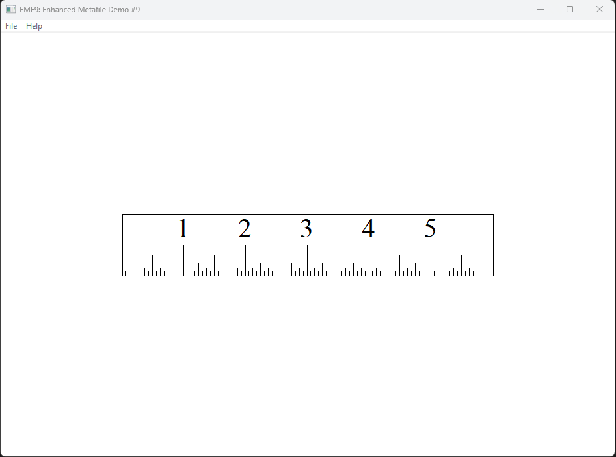

4. Conclusion:
In summary, this code segment is part of a larger Windows application that deals with enhanced metafiles. It illustrates the loading and drawing of a metafile on a window, considering device characteristics for appropriate scaling. The specific details of window creation and initialization are not provided in this snippet.

EMF10 PROGRAM
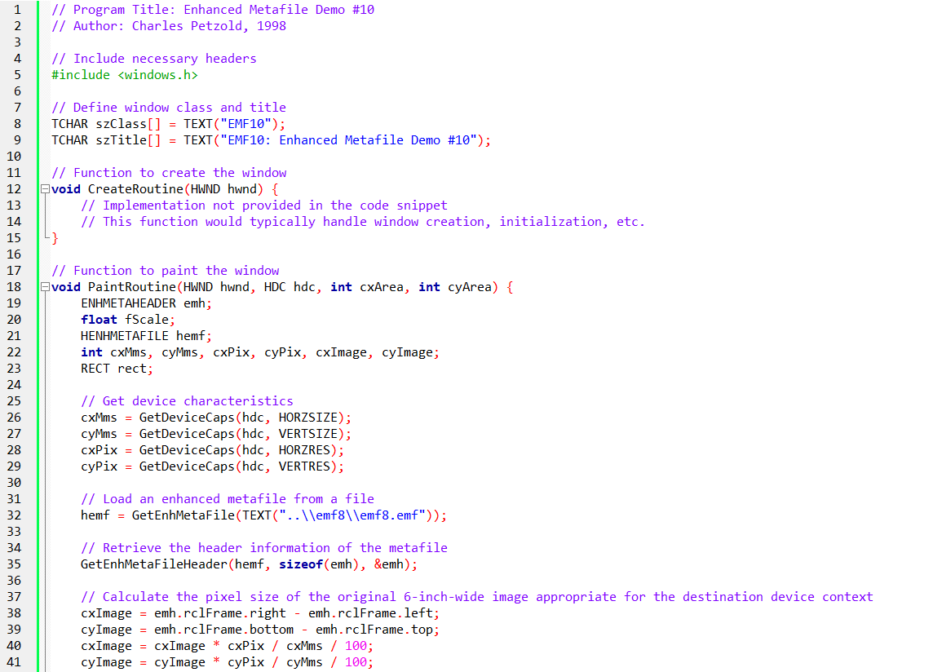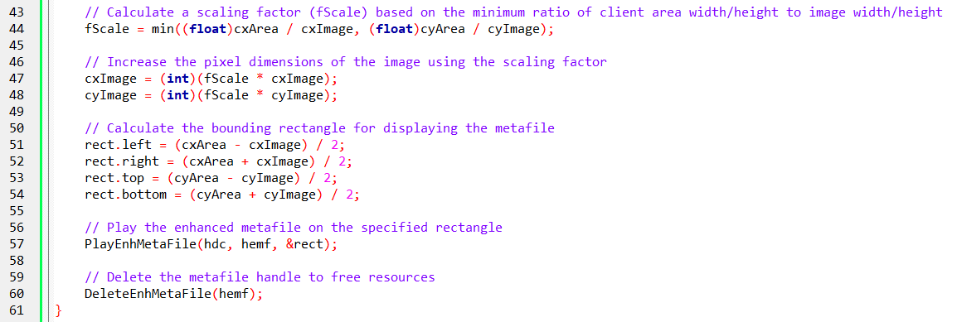

Understanding the Program's Goals:
Preserve Aspect Ratio: The program prioritizes maintaining the ruler image's 6:1 width-to-height ratio, preventing distortions that would occur if it were simply stretched to fit any arbitrary space. This ensures the ruler's visual accuracy and consistency across different display areas.
Adapt to Display Constraints: It adapts to the available client area (the visible portion of a window or the printable area of a page), ensuring the ruler fits within these boundaries without exceeding them. This adaptability makes it suitable for a variety of display environments.
Center Image for Visual Balance: The program centers the ruler within the available space, either horizontally or vertically depending on the client area's dimensions. This creates a visually pleasing and well-balanced presentation.

Key Steps and Concepts:
Leveraging Enhanced Metafiles (EMFs): The program demonstrates the power of EMFs, a file format that stores graphical instructions rather than raw image data. This enables consistent rendering across different devices and resolutions, ensuring the ruler's accuracy.
Respecting Device Capabilities: It emphasizes the importance of understanding device characteristics, such as resolution and size, to ensure proper scaling and display of the ruler. This highlights the need for software to adapt to different hardware environments.

Calculating Optimal Scaling:
The program employs a clever approach to scaling:
- It determines a scaling factor that respects both the client area's dimensions and the ruler's aspect ratio.
- This ensures the ruler fits within the available space without stretching or compressing its shape.

Centering for Visual Harmony:
The calculation of a centered rectangle for image placement demonstrates attention to visual presentation. Centering the ruler creates a balanced and aesthetically pleasing layout.
Utilizing Key Functions: The program effectively leverages Windows API functions for metafile handling and image rendering:
- GetEnhMetaFile retrieves the ruler's design and measurements from the EMF file.
- GetDeviceCaps gathers information about the output device.
- PlayEnhMetaFile follows the EMF's instructions to draw the ruler accurately.

In Conclusion:
This program showcases crucial concepts in graphics programming:
- Preserving aspect ratios during resizing to maintain image integrity.
- Adapting to varying display environments for flexibility and compatibility.
- Utilizing device-independent graphics formats for consistent rendering.
- Understanding device capabilities for accurate image scaling and positioning.

EMF11 PROGRAM
Key Concepts:
Mapping Modes and Metafiles: The program explores the challenges and potential pitfalls of using mapping modes with metafiles, which can introduce complexities when scaling and displaying images across different devices.
Enhanced Metafile (EMF) Creation: It creates an EMF file named "emf11.emf" to store the ruler's graphical instructions.
Mapping Mode Experimentation: It attempts to use the MM_LOENGLISH mapping mode to draw the ruler in inches directly within the EMF, but highlights potential issues with this approach.

CreateRoutine:
- Creates a metafile device context (hdcEMF) using CreateEnhMetaFile.
- Sets the mapping mode to MM_LOENGLISH for drawing in inches.
- Calls DrawRuler to create the ruler graphics within the metafile.
- Closes the metafile using CloseEnhMetaFile and retrieves its handle (hemf).
- Deletes the metafile handle to free resources.

DrawRuler:
- Draws a black rectangle, tick marks, and numbers to represent a 6-inch ruler.
- Uses a 1-point pen width for accuracy in inches.
- Adjusts rectangle coordinates for visual consistency across Windows versions.
- Creates a font with a height of half the ruler's height for proper scaling.
- Aligns numbers at the bottom and center of each inch.

PaintRoutine:
- Retrieves device characteristics for scaling calculations.
- Loads the EMF file using GetEnhMetaFile.
- Retrieves the EMF header information.
- Calculates the ruler's dimensions in pixels based on device characteristics.
- Determines a centered rectangle for displaying the ruler within the available area.
- Plays the metafile using PlayEnhMetaFile to render the ruler.
- Deletes the metafile handle to free resources.

Key Considerations:
- Mapping Mode Confusion: The program highlights that using mapping modes with metafiles can lead to unexpected results when played back on different devices.
- Manual Calculations: It emphasizes the importance of understanding device characteristics and performing manual scaling calculations to ensure consistent rendering across various output contexts.
- Pixel-Based Approach: The previous programs (EMF8-EMF10) demonstrate a more reliable approach using pixel-based calculations for device-independent ruler display.

Mapping Mode Considerations:
The choice of mapping mode can have a significant impact on the visual representation of a metafile. For example, different mapping modes can affect the scaling, positioning, and orientation of objects within the metafile. It's important to understand and consider the behavior of different mapping modes to achieve the desired results.
When selecting a mapping mode, it's essential to take into account the characteristics of the target output device. Different devices may have different resolutions, aspect ratios, or physical dimensions. Choosing an appropriate mapping mode for each output device can help ensure consistent and accurate rendering across different platforms and devices.

Rectangle Adjustments:
In the code example provided, there are adjustments made to rectangle coordinates in the DrawRuler function. These adjustments are likely done to compensate for differences in how different versions of Windows handle the drawing of rectangles. The specific reasons behind these adjustments are not explained in the code snippet, but they are likely related to variations in coordinate systems or rendering behaviors across different Windows versions. These adjustments aim to achieve visual consistency and compatibility across different Windows platforms.

Alternative Approaches:
While the code demonstrates the use of mapping modes to simplify metafile creation, there are alternative approaches to achieve device-independent graphics rendering. One such approach is using matrix transformations, which allow you to apply scaling, rotation, translation, and other transformations to objects.
This can be useful for achieving more complex transformations or effects. Another approach is to implement custom scaling functions that adjust the coordinates and dimensions of objects based on the target device's characteristics. Exploring these alternative techniques can provide more flexibility and control in graphics rendering.

Scalability:
The code examples provided in the snippet focus on fixed-size rulers. However, extending the concepts to dynamically scalable graphics elements would enhance the program's versatility. By incorporating techniques like variable scaling factors or user-defined scaling, you can create graphics that adapt to different display scenarios or user preferences. This can be particularly useful in applications or interfaces that need to support different screen resolutions or device sizes.

Performance Considerations:
It's important to consider the potential performance implications of using mapping modes within metafiles, especially for complex graphics. Some mapping modes may involve additional calculations or transformations, which can impact rendering performance.
It's recommended to evaluate the performance of your graphics operations and consider optimizations if necessary. Techniques like caching or pre-rendering certain elements can help improve performance when working with large or complex metafiles.

Error Handling and User Feedback:
To enhance the code's robustness and user experience, it's valuable to include error handling mechanisms. This can involve checking for errors returned by functions, handling exceptions, or providing informative error messages to the user.
Additionally, providing feedback to the user during long operations, such as printing or rendering, can improve the perceived responsiveness of the program. Progress indicators or status messages can help keep the user informed about the ongoing operations and any potential issues encountered.
Conclusion:
While mapping modes can be useful in certain graphics scenarios, this program demonstrates that careful consideration and manual adjustments are often necessary when working with metafiles to ensure accurate and consistent rendering across different devices.

EMF12 PROGRAM
The code snippet provided is an example of an enhanced metafile (EMF) program. It consists of several functions that create and display a ruler using metafile operations. Let's break down the code and explain its functionality:
DrawRuler: This function is responsible for drawing the ruler using GDI (Graphics Device Interface) operations. It takes an HDC (device context) and the dimensions of the ruler as parameters. The function draws tick marks at different intervals and displays numbers on the ruler.
CreateRoutine: This function creates an enhanced metafile (EMF) by calling CreateEnhMetaFile. It retrieves the device capabilities (size and resolution) using GetDeviceCaps to determine the dimensions and units of the metafile. The DrawRuler function is then called to draw the ruler on the metafile. Finally, the metafile is closed, saved to a file, and deleted.
PaintRoutine: This function is responsible for painting the metafile on a window. It takes an HDC, the window's client area dimensions, and performs the following steps:
- Sets the mapping mode to MM_HIMETRIC, which establishes a logical coordinate system where 1 unit is equal to 0.01 millimeters.
- Sets the viewport origin to the bottom-left corner of the client area using SetViewportOrgEx.
- Converts the client area dimensions from device points to logical coordinates using DPtoLP.
- Retrieves the metafile (emf12.emf) using GetEnhMetaFile.
- Retrieves the metafile header using GetEnhMetaFileHeader to determine the dimensions of the metafile image.
- Calculates the destination rectangle (rect) where the metafile will be displayed. The rectangle is centered in the client area and sized according to the metafile dimensions.
- Finally, it uses PlayEnhMetaFile to render the metafile on the specified HDC within the destination rectangle.
- The line DeleteEnhMetaFile(hemf) after PlayEnhMetaFile appears to be a typographical error and should be removed.

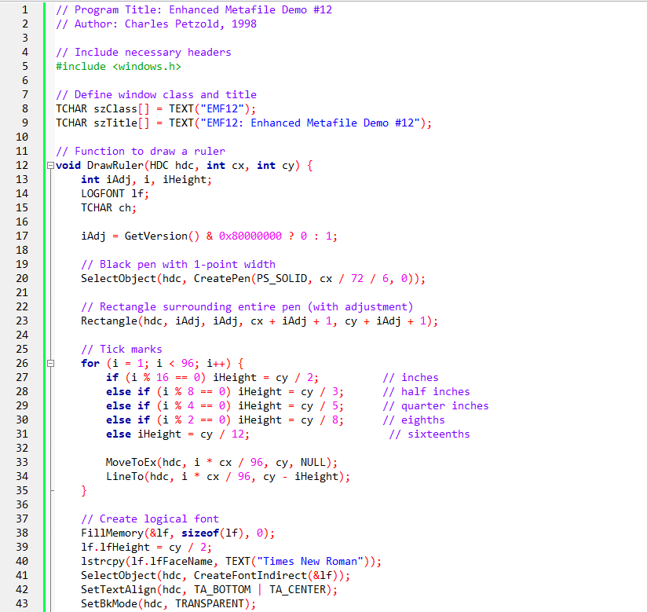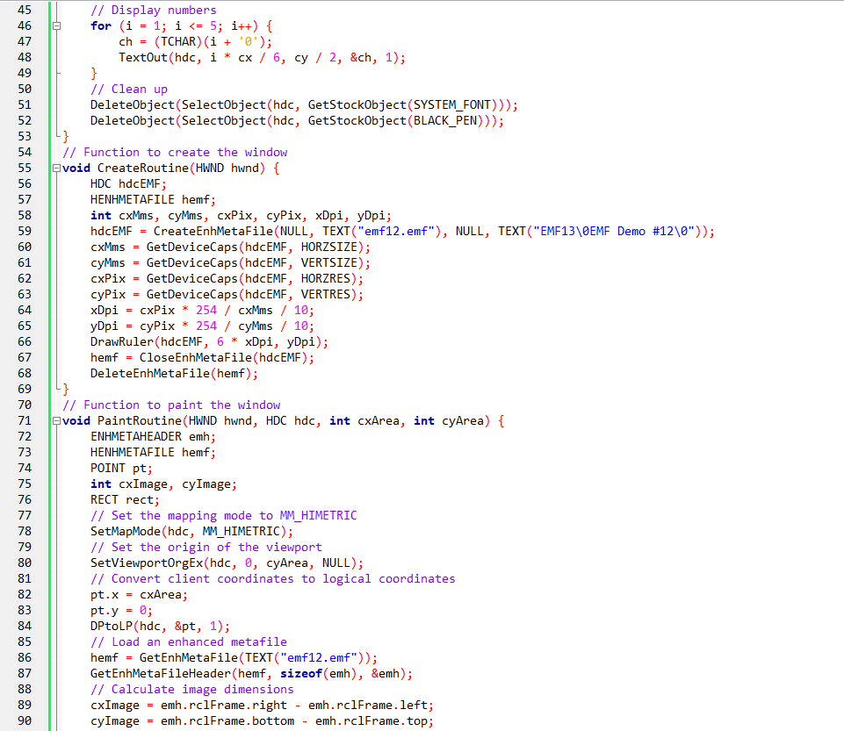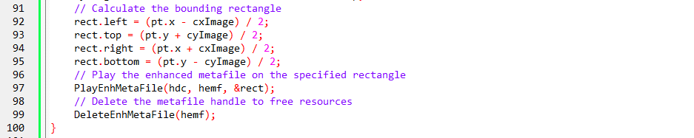

Key Points:
- Mapping Mode for Metafile Creation: EMF12 uses MM_LOENGLISH for drawing the ruler in inches, simplifying metafile creation.
- Mapping Mode for Playback: MM_HIMETRIC is used during playback to align the metafile with the display's size and resolution.
- Viewport Adjustment: SetViewportOrgEx ensures correct vertical positioning.
- Device-Independent Scaling: The program aims to achieve device-independent scaling by combining mapping modes with DPI calculations.
- Potential Issues: Using mapping modes with metafiles can still lead to unexpected results on different devices, requiring careful testing and adjustments.

Overall:
The program demonstrates an approach to simplify metafile creation and scaling using mapping modes, but it highlights the complexities and potential pitfalls of this approach.
This code generates an EMF file containing a ruler and then displays the ruler by playing the metafile using PlayEnhMetaFile with the MM_HIMETRIC mapping mode.
By using MM_HIMETRIC, the logical units of the metafile and the destination rectangle are set to 0.01 millimeters, ensuring consistent scaling and positioning on different devices.

Working with mapping modes and metafiles. Here are a few additional points to consider:
Scaling and Resolution: The code snippet calculates the logical units of the metafile based on the device's resolution and size. This ensures that the metafile is scaled consistently across different devices. However, it's important to note that scaling can affect the visual quality and precision of the graphics. It's recommended to test and verify the desired scaling and resolution for your specific application.
Compatibility with Other Metafile Viewers: While the code demonstrates the creation and playback of metafiles using mapping modes, it's worth considering the compatibility of the generated metafiles with other metafile viewers or editors. Not all viewers may correctly interpret or support mapping modes. If compatibility with third-party applications is a concern, it's advisable to test the generated metafiles in different viewers to ensure proper rendering.
Error Handling: The code snippet provided does not include comprehensive error handling. When working with GDI functions, it's important to handle potential errors and failure cases appropriately. This includes checking the return values of functions, handling resource allocation failures, and providing meaningful error messages or fallback mechanisms when necessary.
Documentation and Code Organization: It's important to document the code and its functionality properly, especially if it's intended for use by other developers or as part of a larger project. Clear comments, function headers, and consistent coding conventions can greatly improve code readability and maintainability.

EMF13 PROGRAM

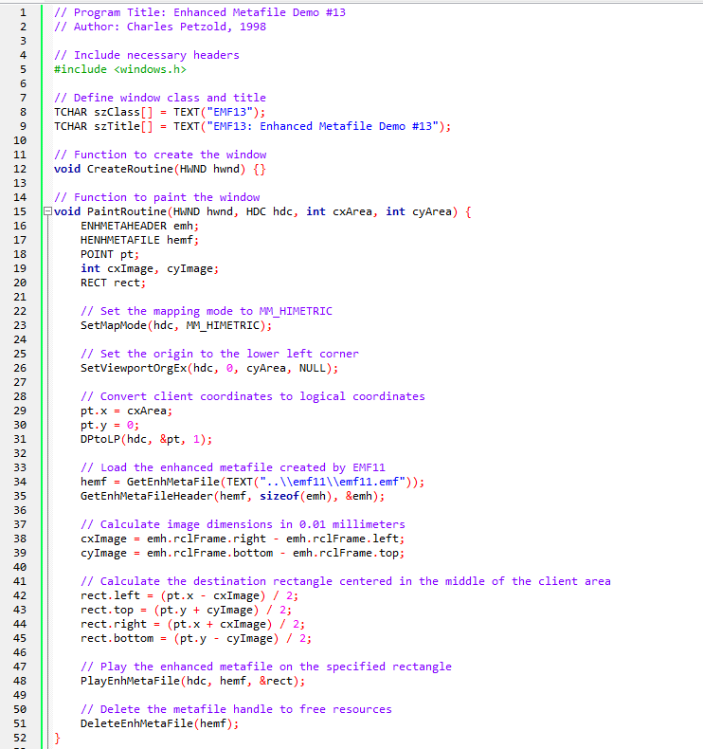
The code snippet demonstrates how to create and paint a window using an enhanced metafile.

The CreateRoutine function is responsible for creating the window. However, in the provided code, the function is empty, indicating that no specific actions are performed during window creation.
The PaintRoutine function is responsible for painting the window. It takes four parameters: hwnd (the window handle), hdc (the device context), cxArea (the width of the client area), and cyArea (the height of the client area).

Here is a step-by-step breakdown of the PaintRoutine function:
Set the mapping mode to MM_HIMETRIC. This mapping mode ensures that the logical units used for drawing are in 0.01 millimeters, providing a consistent scale across devices.
Set the origin of the viewport to the lower-left corner of the client area using SetViewportOrgEx. This adjustment is necessary because the default origin is at the upper-left corner, but with the mapping mode set to MM_HIMETRIC, the y-axis increases upwards.
Convert the client coordinates (cxArea, 0) to logical coordinates using DPtoLP. This conversion ensures that the logical coordinates match the desired scale and units.
Load an enhanced metafile named "emf11.emf" using GetEnhMetaFile. This metafile was presumably created by a previous program (EMF11) and is now being used for rendering.
Retrieve the metafile header using GetEnhMetaFileHeader to obtain information about the metafile's dimensions and other properties. The header is stored in the emh variable.
Calculate the dimensions of the metafile image in 0.01 millimeters by subtracting the left coordinate from the right coordinate for the width and the top coordinate from the bottom coordinate for the height.
Calculate the destination rectangle where the metafile will be displayed. The rectangle is centered in the middle of the client area. The left and right coordinates are calculated based on the logical coordinates and the width of the metafile image. The top and bottom coordinates are calculated in a similar manner. The resulting rectangle is stored in the rect variable.
Use PlayEnhMetaFile to play the enhanced metafile on the specified rectangle within the device context. This function renders the metafile content onto the window.
Delete the metafile handle using DeleteEnhMetaFile to release the resources associated with the metafile.
This code snippet demonstrates the process of loading an enhanced metafile and rendering it on a window using a specific mapping mode. It showcases how to position and scale the metafile content within the window's client area.

In the EMF13 program, the ruler metafile is not created using a mapping mode. It is already created by EMF11. EMF13 simply loads the existing metafile and utilizes a mapping mode to calculate the destination rectangle, similar to how EMF11 operates.
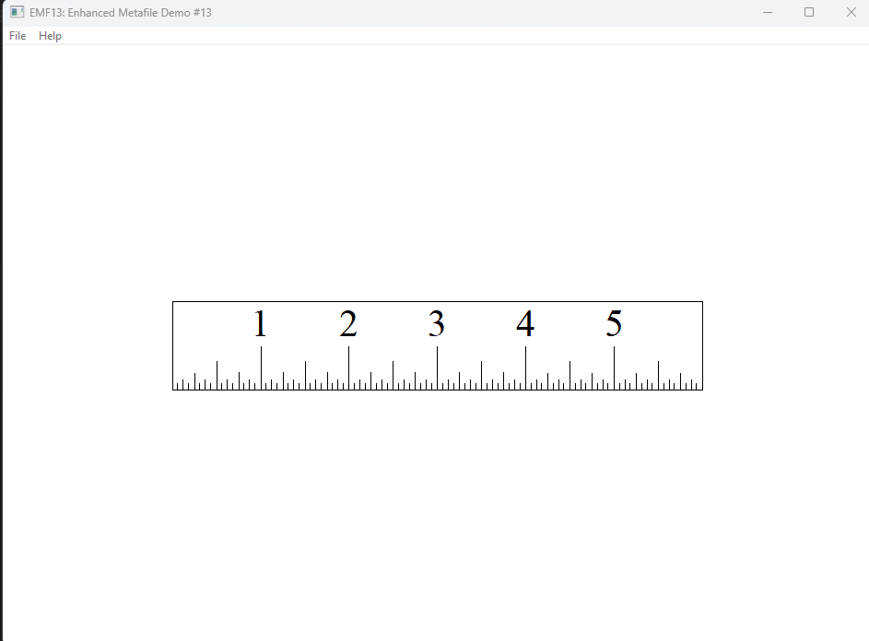
Based on your explanation, we can establish a couple of principles:
Metafile Creation: When a metafile is created, GDI takes into account any embedded changes to the mapping mode to calculate the size of the metafile image in pixels and millimeters. This information is stored in the metafile header. The mapping mode in effect during the creation of the metafile is used to determine the image size.
Metafile Playback: When a metafile is played, GDI determines the physical location of the destination rectangle based on the mapping mode in effect at the time of the PlayEnhMetaFile call. The mapping mode used during playback determines the positioning and scaling of the metafile content within the destination rectangle. Once the mapping mode is set for playback, the metafile itself cannot change the location of the destination rectangle.

These principles highlight the importance of mapping modes during both metafile creation and playback. The mapping mode used during creation affects the size information stored in the metafile header, while the mapping mode used during playback affects the positioning and scaling of the metafile.
It's worth noting that the mapping modes used during creation and playback should be chosen carefully to ensure consistent and desired results. Changes to the mapping mode between creation and playback can lead to unexpected positioning and scaling of the metafile content.

